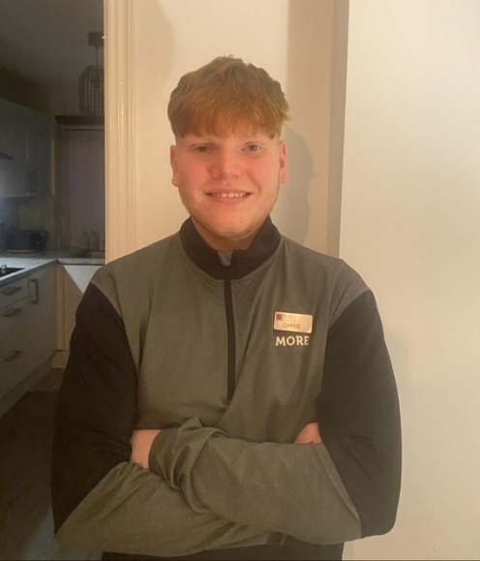





My specialties
- General fitness and starting with gym basics
- Resistance Training (weights)
- Strength Improvement & Conditioning
- HIIT, Endurance and circuit training
- Lean Muscle Building
- Functional Fitness
- Core stability and so much MORE!
About me

Hello, my name is Chris and I’m a qualified personal trainer, with an ambition to support and help my clients improve their health and wellbeing through fitness.
I’ve worked at Northfield Leisure Centre for the last 8 months and I’ve worked with different types of clients. I also have experience with training different type of sports athletes and gym athletes.
I’m also doing a level 4 and level 5 Sports coaching and performance science degree from Newman University; I’m only in my first year but hopefully by the end of my degree I can support you with different injuries and help you with injury prevention and give you different advice.
I can support achieving the following goals:
- Weight loss and fitness confidence
- Improving your stability, speed, power, and endurance.
I will also create you a personalised and exciting training plan, to keep you motivated and on track with your goals!

Gym floor classes
Circuits
FITIN30

Gym Instructor
Level 2

I’m regulated by:
The Chartered Institute for the Management of Sport and Physical Activity (CIMSPA) Member number 35366

My Qualifications
Personal Trainer Level 3

PERSONAL TRAINER PROFILE

Christopher
Burbidge

How do you book me?
Email: Christopher.burbidge16@gmail.com
or ask at reception for more details.

